Unit 9 test
Vocabulary
Vocabulary
1 Look and tick ().
 | 1 A ☐ shelf  B ☐ armchair
 | 2 A ☐ vase  B ☐ fireplace
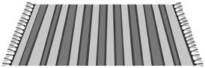 | 3 A ☐ coffee table  B ☐ rug
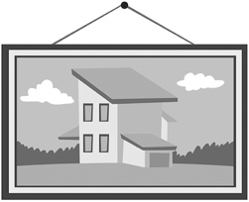 | 4 A ☐ curtains  B ☐ painting
/ 4
2 Look, read and number.
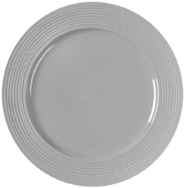 | 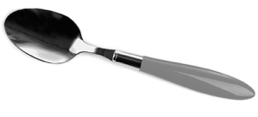 | 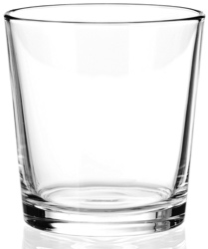 |  | fork  jug  spoon  knife  plate  glass
1 | 2 | 3
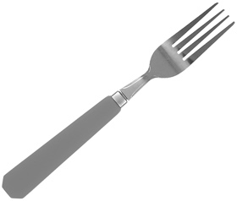 | 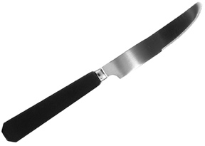 | 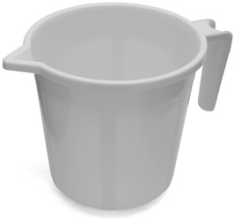
4 | 5 | 6
/ 6

Grammar
3 Look at the picture. Read the sentences and circle.
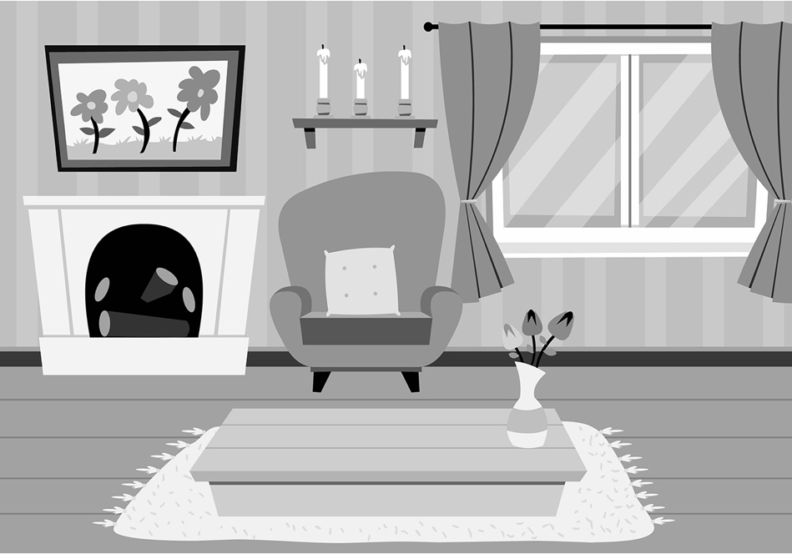
1 There are … flowers in the vase. some / a
2 There isn’t … rug on the coffee table. any / a
3 There are … flowers in the painting. three / a
4 There aren’t … trees in the painting. any / some
5 There’s … coffee table in the living room. some / a
/ 5
4 Look, read and circle.
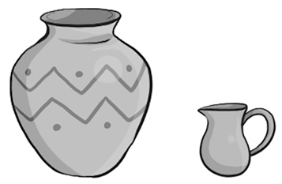 | 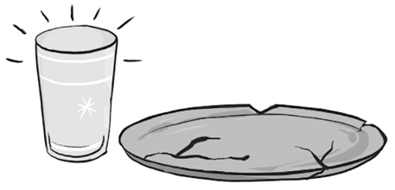 | 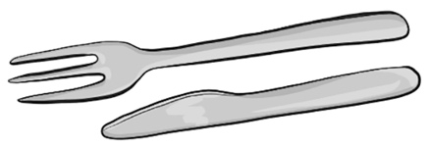
1 The jug is bigger / smaller than the vase. | 2 The plate is newer / older than the glass. | 3 The knife is shorter / longer than the fork.
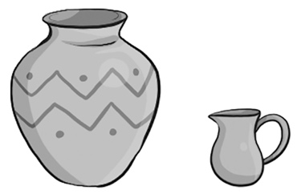 |  | 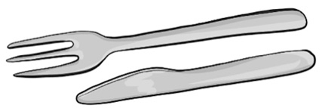
4 The vase is smaller / bigger than the jug. | 5 The glass is newer / older than the plate. | 6 The fork is longer / shorter than the knife.
/ 6
Reading
5 Read and complete with one word.
Subject: Emi’s visit
Hi! I’m visiting Kastanea with my parents. Kastanea is a small town in Greece. The houses in Kastanea are beautiful. You climb up stairs to my grandmother’s house. There is a big living room in Gram’s house, but the kitchen is bigger. There is a long table in the kitchen. There is a vase on the table. There are some flowers in the vase. There are six chairs, too. There are red and blue cushions on the chairs. The walls in the kitchen are white.
In winter, there are rugs on the walls. I love my grandmother’s house because it is cold in summer and hot in winter.
1 Emi is in Kastanea with her .
2 There are you can climb to Emi’s grandmother’s house.
3 The kitchen is than the living room.
4 The cushions on the chairs are red and .
5 Emi’s grandmother’s house is in summer.
/ 5
Writing
6 Rewrite the sentences with because.
1 It’s hot. It’s summer.

2 I love the house. It’s my grandmother’s house.

3 There aren’t lots of people. The town is small.

4 There aren’t any chairs. There’s a big sofa.

/ 4

Listening
7  9 Listen and circle the tick () or the cross ().
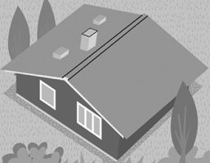 | 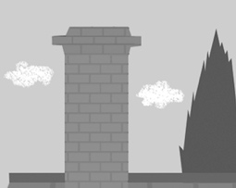 | 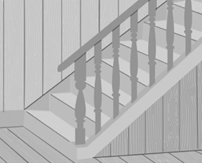
1 / | 2 / | 3 /
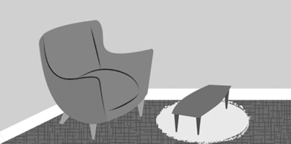 | 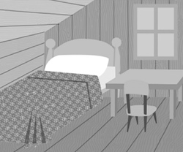
4 / | 5 /
/ 5
Speaking
8 Look, read and answer.
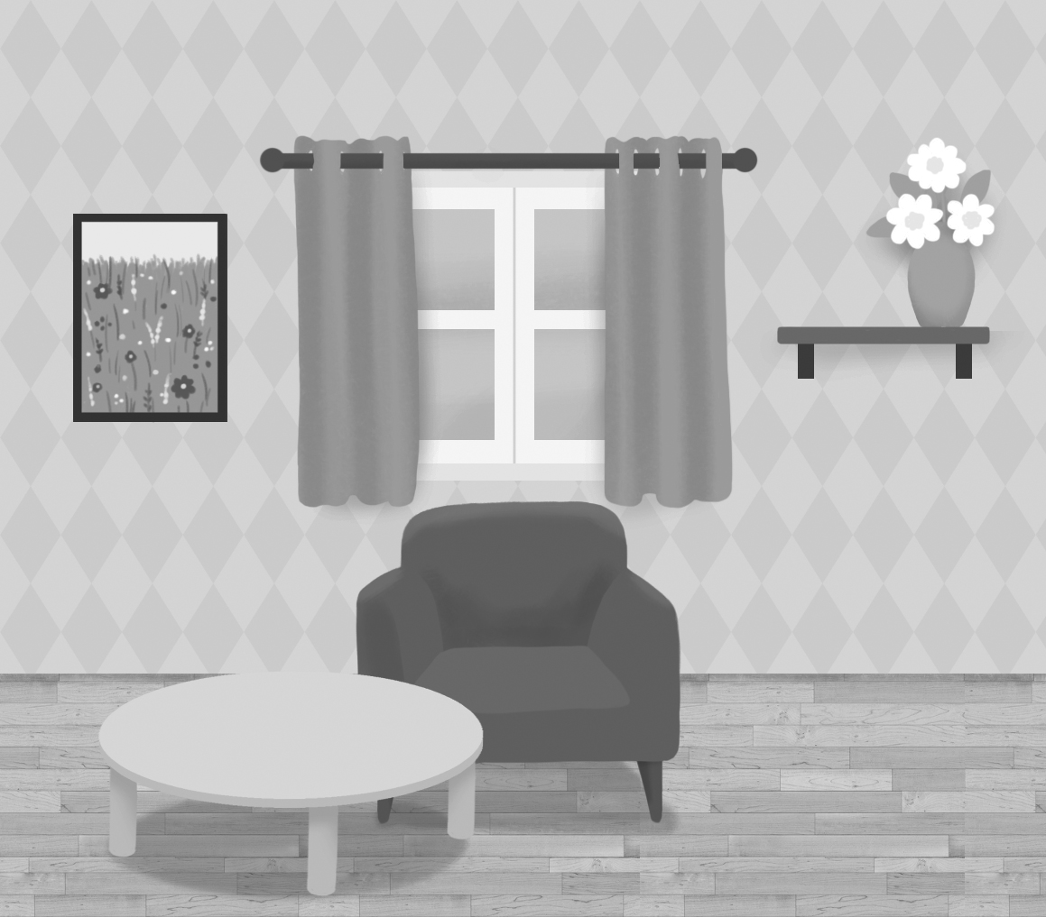
1 Is there a living room
in the house?
2 Is there a shelf in the
living room?
3 Is there a vase on the shelf?
4 Are there some flowers
in the vase?
5 Are there any cushions
on the armchair?
/ 5
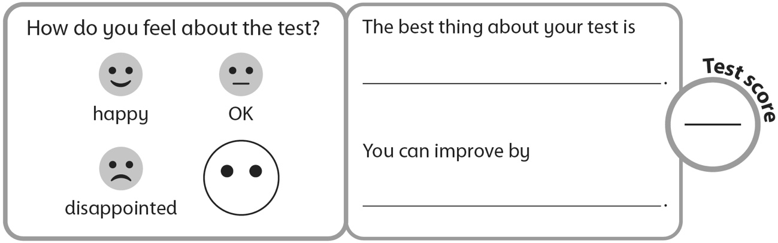
40

